
FOUNDATIONAL C++ FOR ROBOTICS LAB
Department: Department of Computer Science and Engineering / Robotics
Course Name: Fundamental C++ for Robotics
Course code: - ETCCCPL205
Program Name: Cse (Robotics and AI)
Student Name: Ajitesh Singh Gusain
Roll No.: 2501630014
Faculty Name: Himanshu Kaushik

Unit -1: C++ Fundamentals and IDE Setup

Lab experiment - 1.
- Environment setup: To get started, we need some essential tools. This task is to ensure that my computer can "talk" to my code. We have to install MinGW-w64 (for G++). Editor: Use Visual Studio Code with Microsoft's "C/C++" extension.
First Robotics Program using GCC/G++
Code implementation:

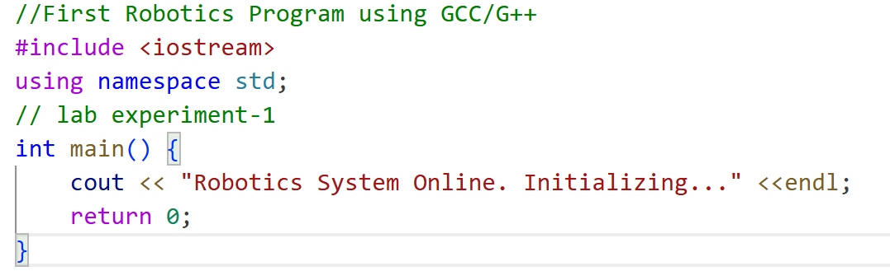
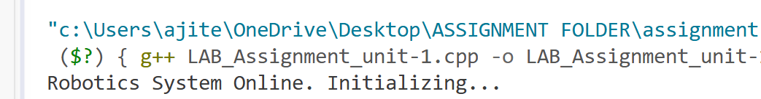Lab experiment - 2.
Development of an Obstacle Distance-Based Robot Decision System using if-else Conditional Control Logic
This mimics how a robot decides what to do when a sensor detects an object.
Code implementation:

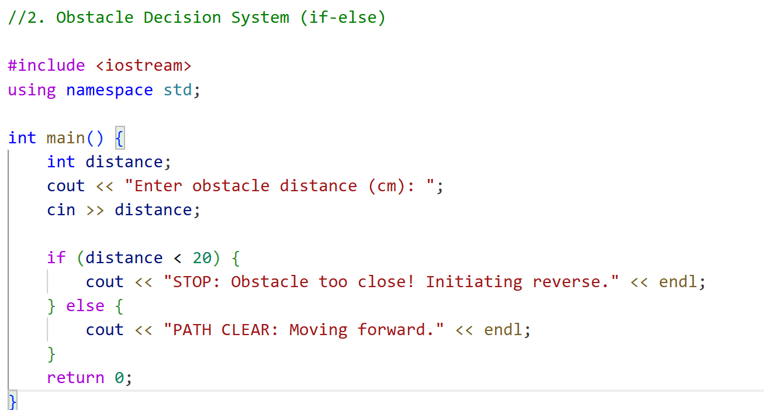
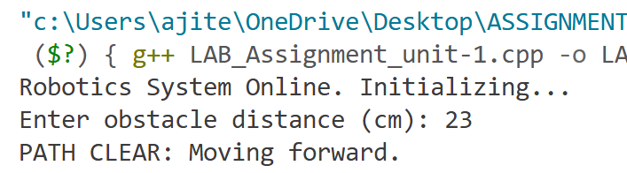Lab experiment - 3.
Simulation of Repetitive Robot Movement using for, while, and do-while Loop Constructs
Robots often perform repetitive tasks, like scanning an area or rotating wheels.
Code implementation:

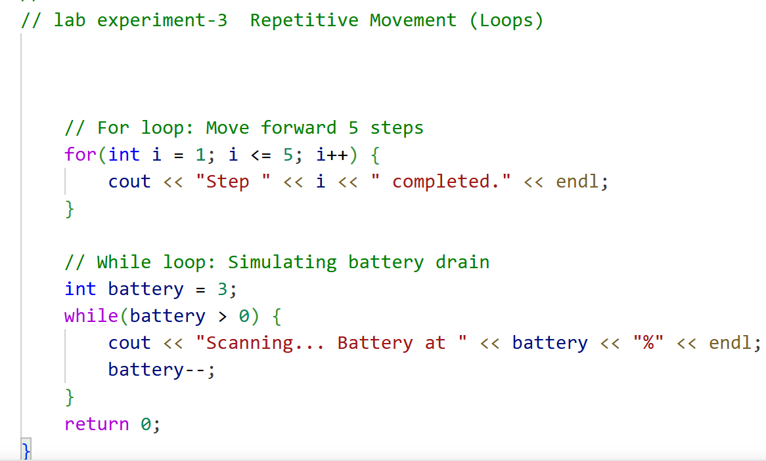
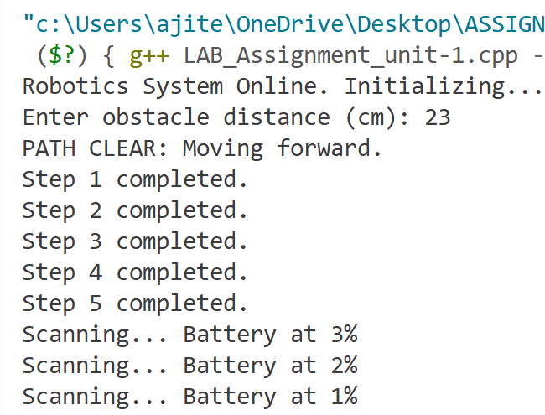
Lab experiment - 4.
Modular Operations (Functions)
Functions keep your code clean by separating tasks like "move" and "turn."
Code implementation:
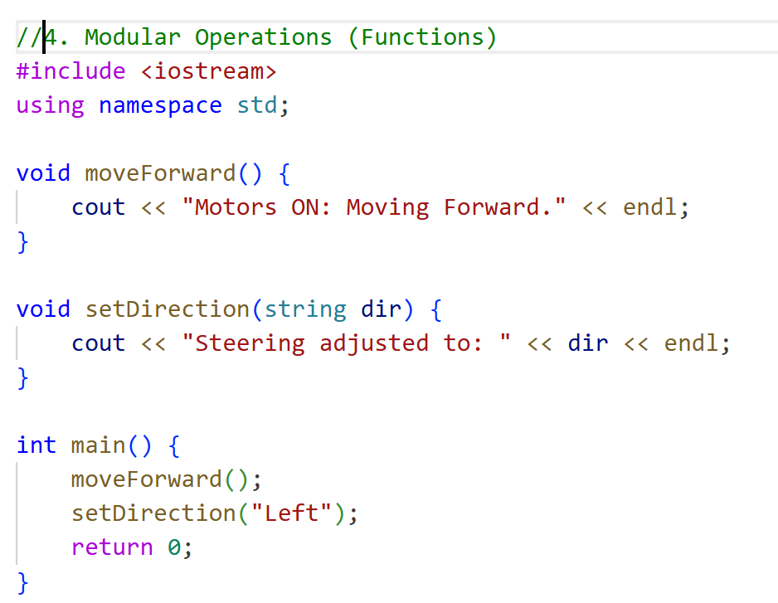
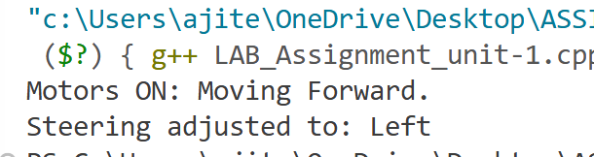
Lab experiment - 5.
Function-Based Implementation of Modular Robotic Operations for Forward Movement and Direction Control
This allows a user to control the robot by choosing from a list of commands.
Code implementation:

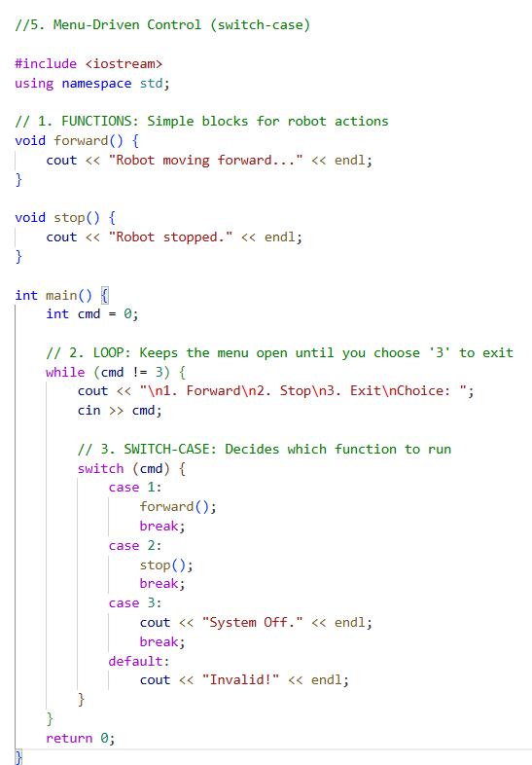
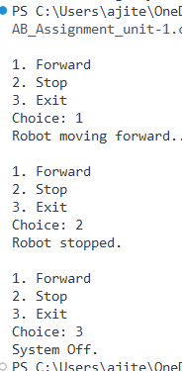

Unit -2: Memory and Data structures

Lab Experiment-6
Analysis of Stack, Static, and Heap Memory Allocation through a C++ Memory Layout Visualization Program
This shows where variables live in your computer's memory.
Code implementation:

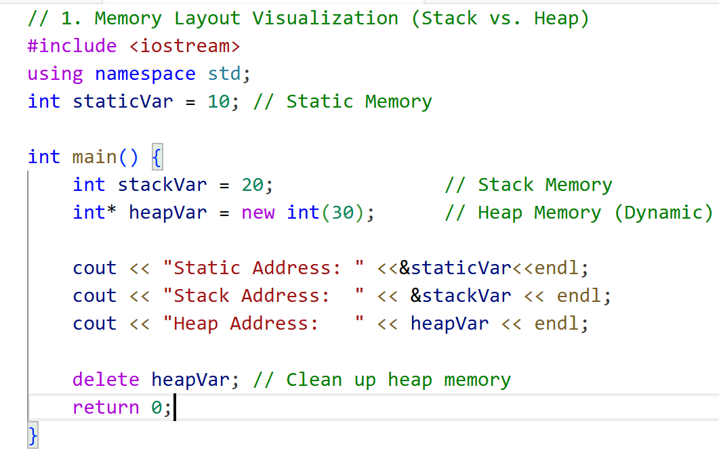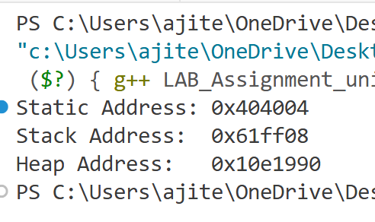

Lab Experiment-7
Analysis of Stack, Static, and Heap Memory Allocation through a C++ Memory Layout Visualization Program
Used when a robot doesn't know how many sensor readings it will take in advance.
Code implementation:

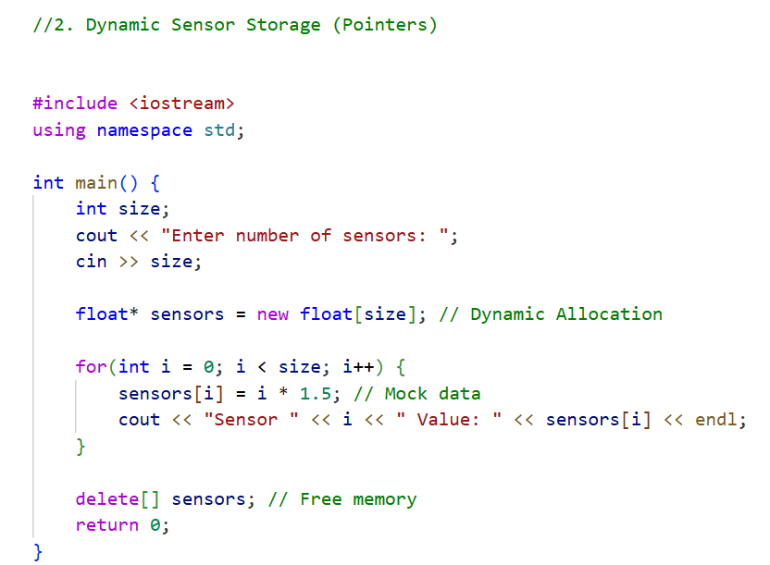

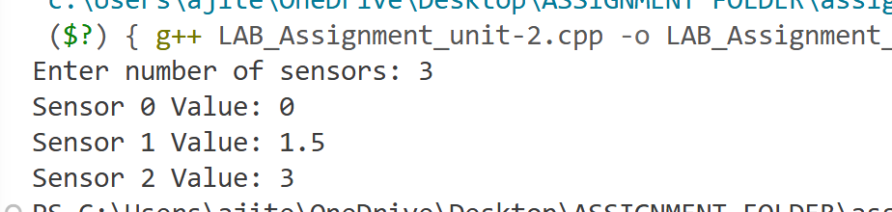

Lab Experiment-8
Implementation of Dynamic Sensor Data Storage and Processing using Pointers and Dynamic Memory Allocation in C++
A vector is a list that grows automatically—perfect for tracking a robot's path.
Code implementation:

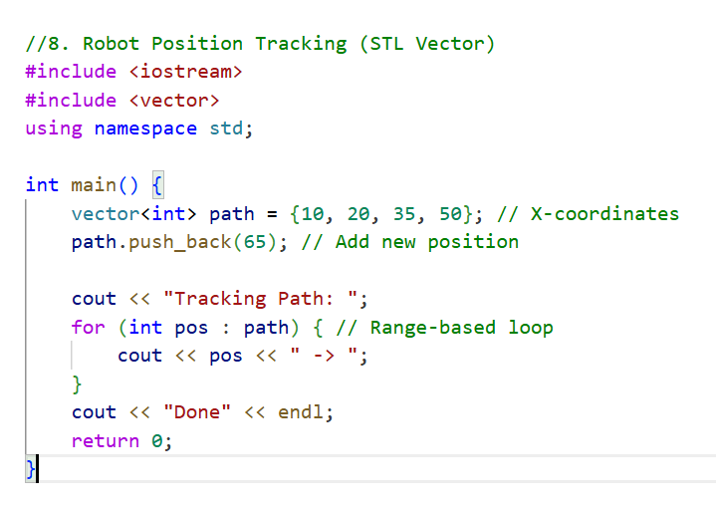
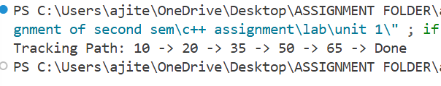

Lab Experiment -9
Command Buffer (STL Queue - FIFO)
"First-In, First-Out" (FIFO). The robot executes commands in the order they were received.
Code implementation:

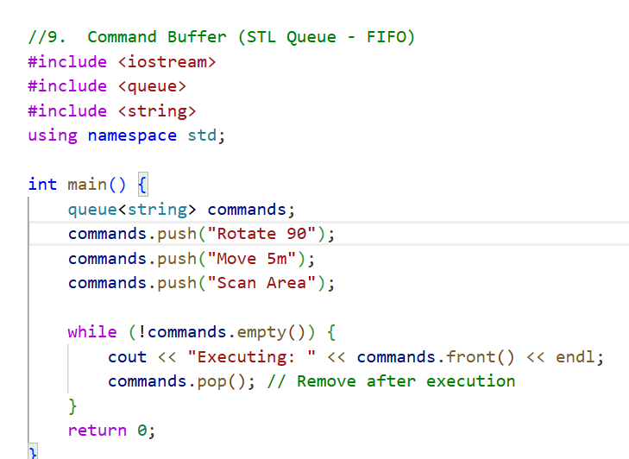
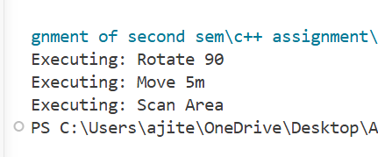

Lab Experiment -10
Safe Sensor Input (Exception Handling)
This prevents the robot "crashing" if it receives impossible data (like a negative distance).
Code implementation:

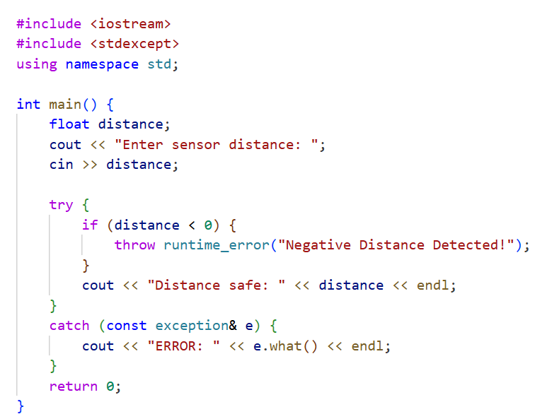
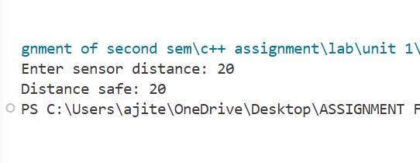

Unit -3 : Object -Oriented Programming for Robotics

Lab experiment - 11. Design of a Robotic Actuator Control Class using Object-Oriented Programming Principles and Encapsulation
We hide the internal state (like position) using the private keyword. Access is only allowed through the moveTo() method, which includes safety checks to prevent hardware damage.
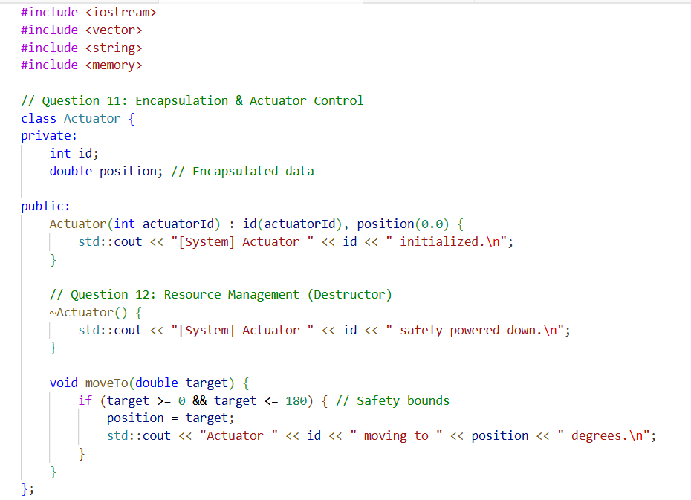

Lab experiment - 12. Implementation of Constructors and Destructors for Safe Lifecycle and Resource Management in Robotic Objects
The constructor handles the "power-on" sequence, while the destructor ensures that when an object goes out of scope, resources are released and the hardware is left in a safe state.
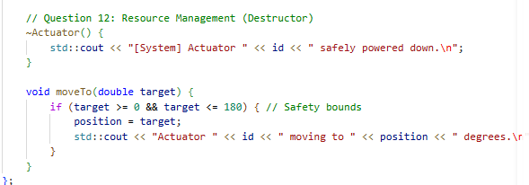
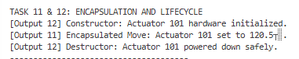

Lab experiment - 13. Development of a Robot Class Hierarchy using Inheritance and Runtime Polymorphism for Multiple Robot Types
The base Robot class defines a generic interface. Subclasses like Drone and Rover provide specific implementations. Using virtual functions allows us to manage a variety of robot types within a single list (polymorphism).
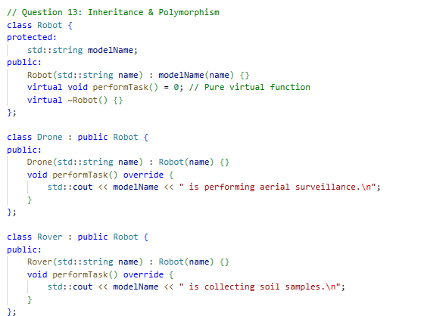
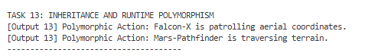

Lab experiment - 14. Design of an Integrated Robot System using Composition-Based Modeling of Sensors and Controllers

Instead of the IntegratedRobot being an Actuator, it contains one. This "Has-A" relationship is often more flexible than inheritance, allowing us to build complex machines from simpler, modular components.
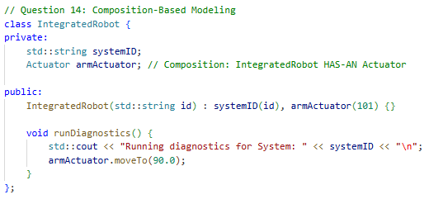
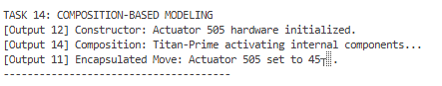
Lab experiment - 15. mplementation of Safe Ownership and Automatic Resource Cleanup in Robotic Systems using Smart Pointers
To prevent memory leaks, we use smart pointers. They automatically delete the robot objects when they are no longer needed, removing the risk of "dangling pointers" or manual delete errors.
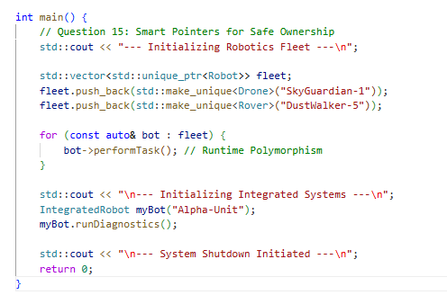
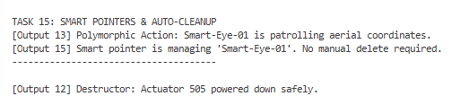

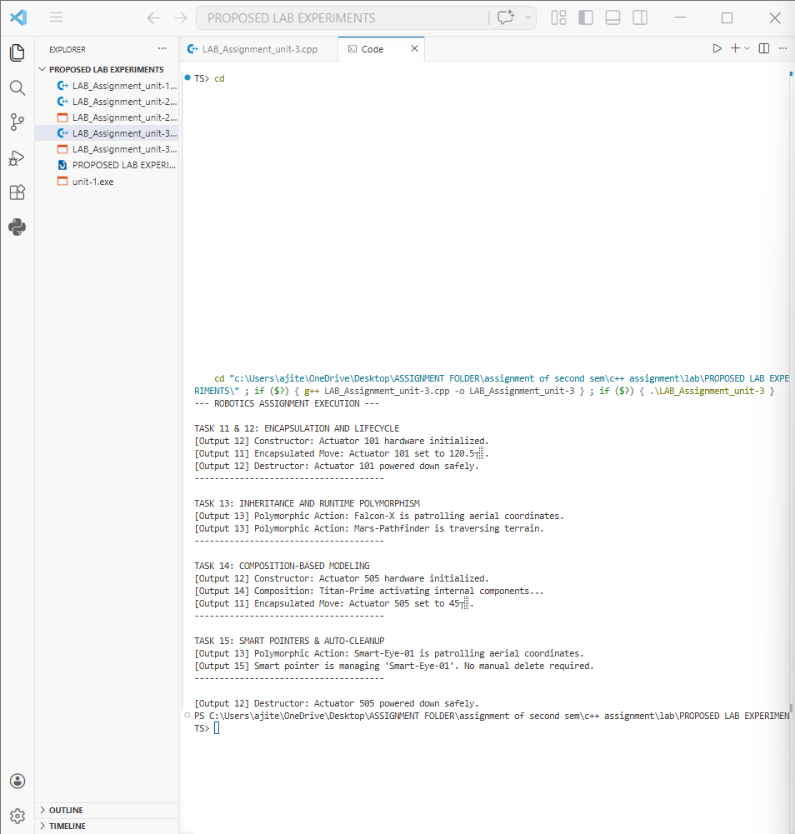
Unit -3 : Embedded Thinking & Real -Time Constraints

Lab experiment - 16. Design and Implementation of Embedded-Style Robot Status Management using Bitwise Flags and Enumerations
• Uses Bitwise Flags to store multiple robot states in a single byte, optimizing memory for embedded hardware.
•

Lab experiment - 17. Measurement and Profiling of Sensor Function Execution Time using chrono for Latency Analysis in Robotics Applications
Employs the Chrono library to measure sensor execution time, ensuring processing stays within microsecond limits.

Lab experiment - 18. Implementation of Sensor Data Serialization and Deserialization using C++ Structures and Byte-Level Data Packing
Implements Data Serialization to pack sensor structures into raw bytes for efficient transmission between robot components.

Lab experiment – 19. Development and Timing Enforcement of a Periodic Real-Time Control Loop for Simulated Robotic Operations
Develops a Periodic Control Loop using sleep_until to maintain a strict, steady frequency for stable motor movements.

Lab experiment - 20. Evaluation of Deadline Satisfaction, Jitter, and Safety Constraints in a Real-Time Robotic Control Loop through Timing Analysis Report
Evaluates Deadline Satisfaction by analyzing timing jitter, ensuring the system remains safe and responsive under load.

